**MCT-115 Engineering Statics**



**Complex Engineering Problem**

**Submitted by:**

Dayan Hafeez 2021-MC-12

Muhammad Usman Noor 2021-MC-16

**Submitted to:**

Ms. Qurat Ul Ain Masud

**Department of Mechatronics & Control Engineering**

**University of Engineering & Technology, Lahore.**

June-2022

**Contents**

Introduction 2

Types: 2

Howe truss: 3

Warren truss: 3

Pratt truss: 3

Selected bridge design: 4

Significance of the selected Bridge design or Selection criteria of the design: 4

Mathematical Analysis: 5

Static determinacy: 10

Steps to build a bridge: 11

Results & Discussion: 12

Pictures: 12

Loading capabilities: 12

Failure: 13

References: 13

Software used: 13

# Introduction

Spanning relatively long distances is a common challenge in engineering and architecture. Designing a structure to safely support itself and resist the forces of human activity and Mother Nature becomes more challenging as humans continue to push construction technology to new lengths (and heights)—designing ever taller and more expansive structures. Trusses are often a solution to these *taller*, *longer*, and *bigger* structural challenges.

A **truss** is an assembly of *members* such as [beams](https://en.wikipedia.org/wiki/Beam_(structure)), connected by *nodes*, that creates a rigid structure

In engineering, a truss is a [structure](https://en.wikipedia.org/wiki/Architectural_structure) that "consists of two-force members only, where the members are organized so that the assemblage as a whole behaves as a single object" A "two-force member" is a structural component where force is applied to only two points. Although this rigorous definition allows the members to have any shape connected in any stable configuration, trusses typically comprise five or more triangular units constructed with straight members whose ends are connected at joints referred to as [nodes](https://en.wikipedia.org/wiki/Vertex_(geometry)). The two-force member are only tension or compression. The tension which is going outwards from the sticks & the compression is the force is the one which is going inwards from the joints.

If the truss is built correctly, then it is a very efficient way to span long distances with the very minimum use of the stick and the design is capable of handling more weight.

# Types:

Trusses can be manufactured in a multitude of shapes and configurations. The type and style of truss chosen for a given design depend on the design requirements—including the span (the length between supports), the design load(s), and sometimes (when aesthetics are important) the truss form.

The following are some types of truss bridges:

* Howe truss
* Pratt truss
* K truss
* Warren truss
* 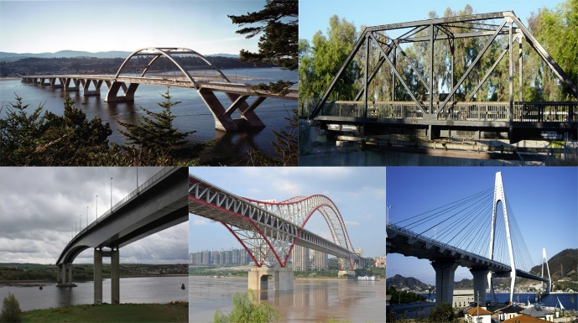Baltimore truss
* Bailey truss
* Bollman truss

## Howe truss:

A Howe truss is a truss bridge consisting of chords, verticals, and diagonals whose vertical members are in tension and whose diagonal members are in compression.

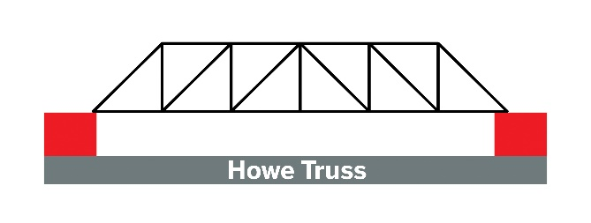The inner truss of a Howe truss is [statically indeterminate](https://en.wikipedia.org/wiki/Statically_indeterminate). There are two paths for stress during loading, a pair of diagonals in compression and a pair in tension. This gives the Howe truss a level of redundancy which allows it to withstand excessive loading (such as the loss of a panel due to Collison).

## Warren truss:

Warren truss is a quite popular structure of truss design and can be identified with ease due to the fact that it’s constructed from triangles that are equilateral. Warren truss design has the capacity to spread the load across a number of members that are different. This load is spread evenly throughout the warren trusses. This also creates, however, a problem. The structure of the warren type truss also then undergoes under a point load, a lot of force that is concentrated. If these loads are concentrated, then in this scenario, the weight is not spread across evenly. This is why a warren type truss bridge is more useful for loads that are or can be spanned. On the other hand, the warren truss is not suitable in the situation where the concentrated load is at a single point or node.

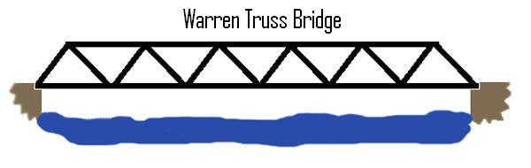

## Pratt truss:

A Pratt Truss is a style of truss which is styled as internal (web) truss members travelling in a diagonal top-down direction. This formation is quite simple and extremely effective in long spans such as bridges. It differs to other [types of trusses](https://skyciv.com/docs/tutorials/truss-tutorials/types-of-truss-structures/), in its simplicity and is most closely related to the Howe Truss, where the diagonal members are in the opposite direction (causing an inverse compression/tension behavior in the members).

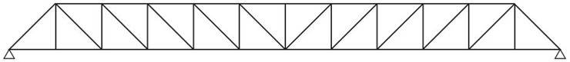

# Selected bridge design:

This bridge design is based on Pratt but basically it is a little bit modified we add some extra zero force member to more structural stability. Although these force members will add in the calculation because these members are statically indeterminant. As shown below.

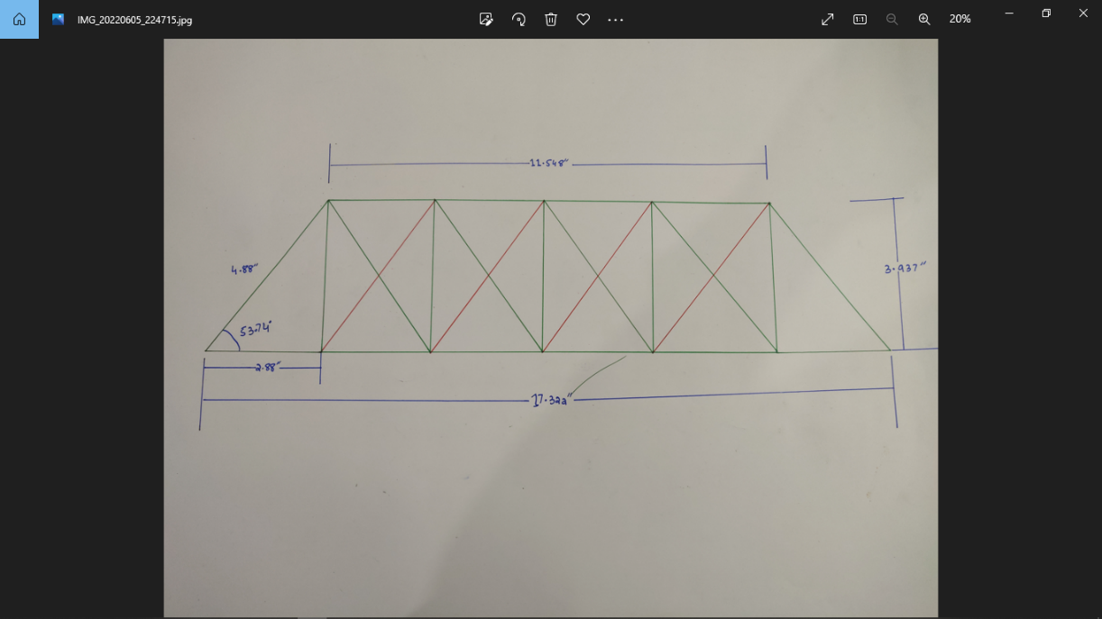

The members which are shown in red color are zero force member

# **Significance of the selected Bridge design or Selection criteria of the design:**

As told earlier this bridge is a Pratt but a modified one so it has more advantages than a Pratt, first thing first it is more stable because of the extra zero force member as shown in the above figure and following are the significance of this bridge.

* It is a Simple Design
* Higher load to mass ratio
* The diagonal members are in Tension as compared to Howe truss
* It is more stable
* It is very similar to Howe
* Effective for compression force
* Useful weight Distribution
* Efficient force Dissipation

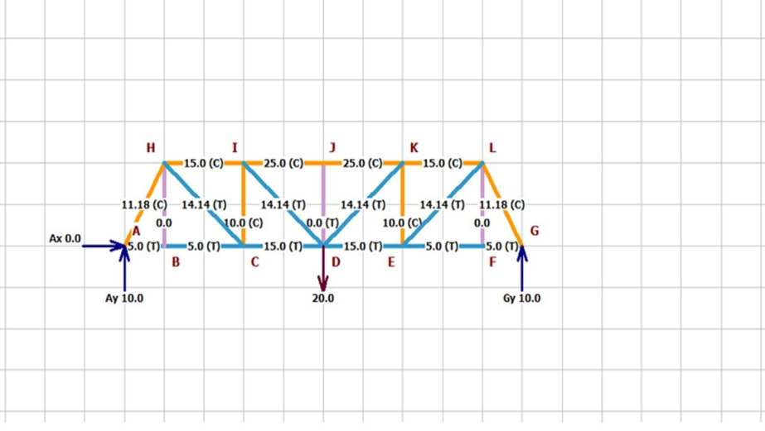

In comparison to Warren truss bridge, it is more efficient as the diagonal members are in tension but in warren some of the diagonals are in compression which is not a good thing for the heavy loads. Warren truss bridge is shown in figure.

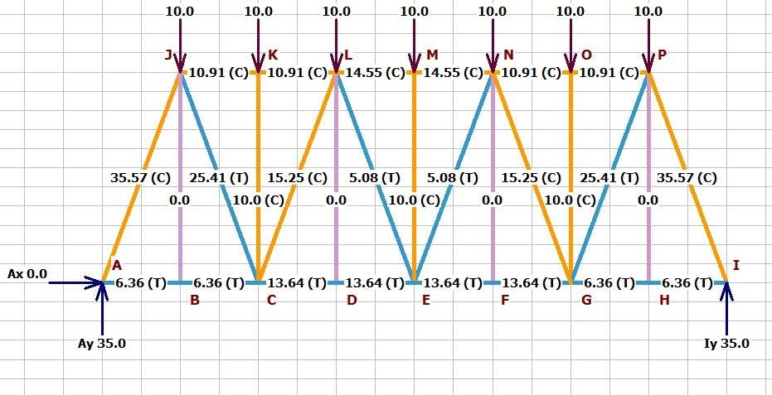

# **Mathematical Analysis**:

Our design is basically a “Pratt style bridge”, but it has some extra members of zero force which are **RED**  diagonal members as shown in the fig below:

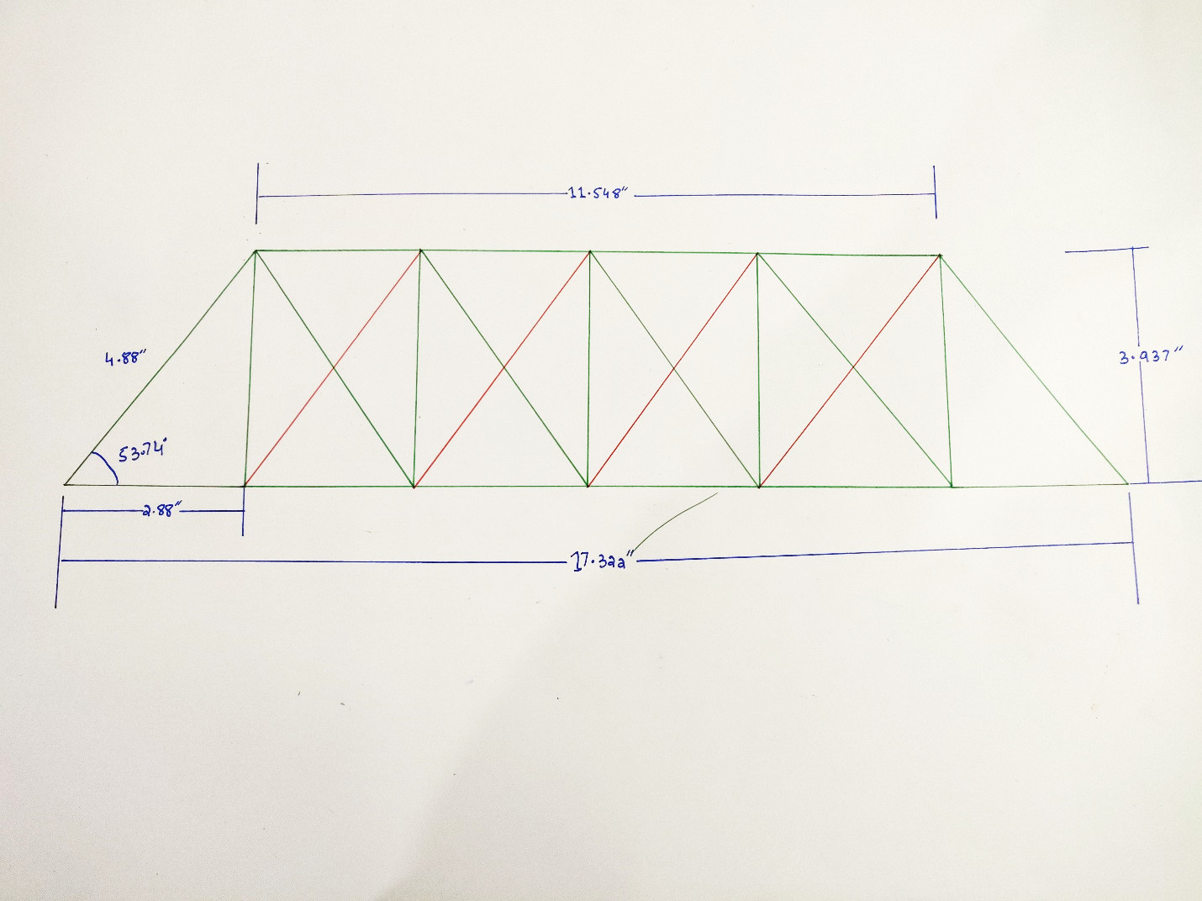

The calculations done are based on basic style of truss design, which is the pratt design.

The details of the calculation is given below:

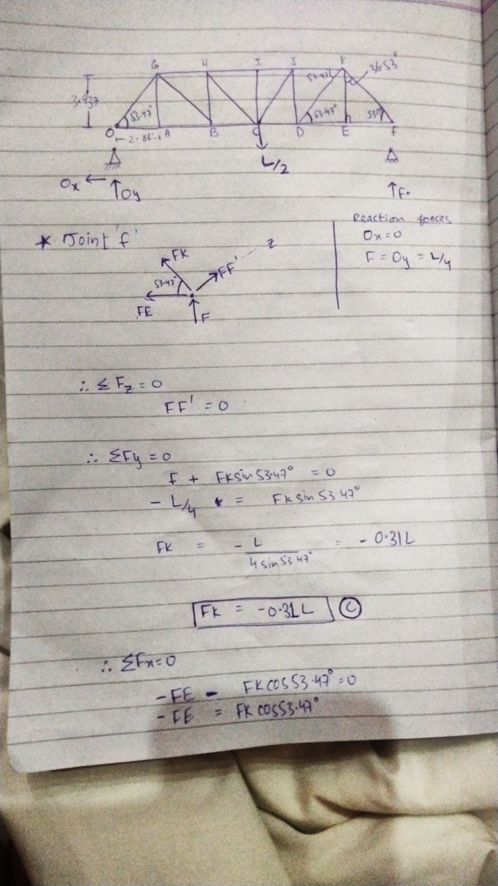

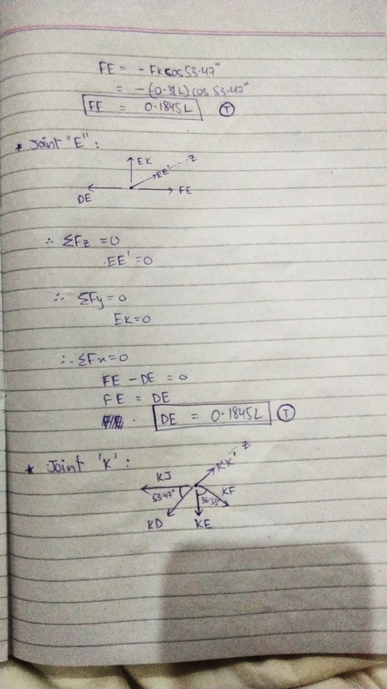

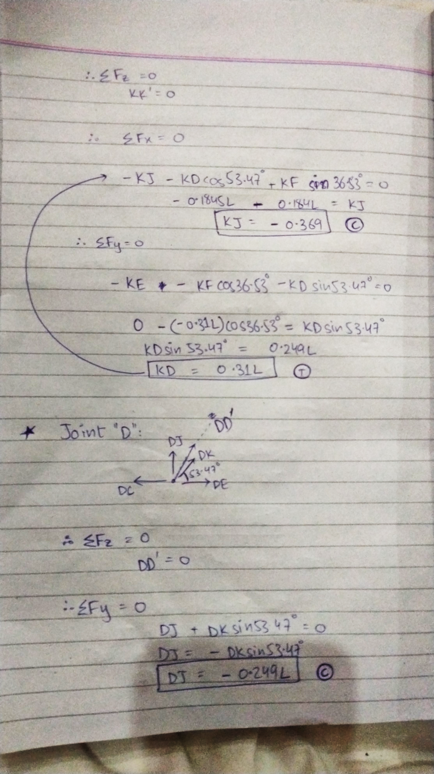

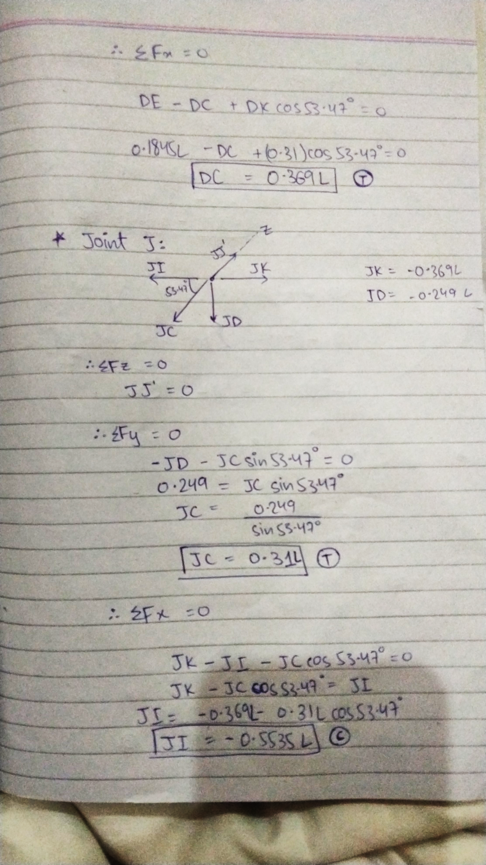

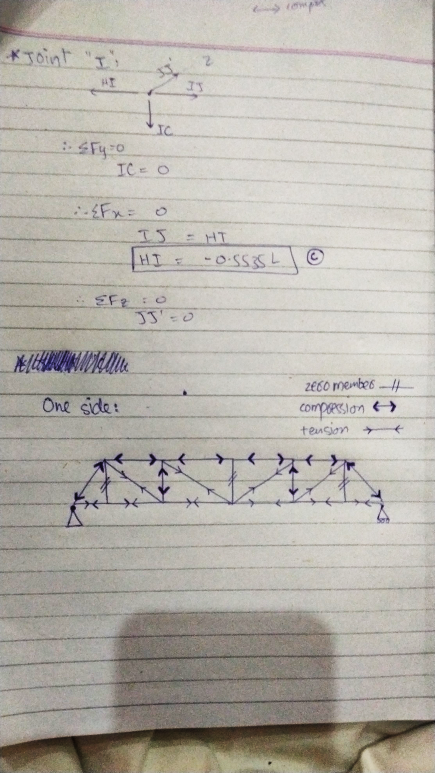

## Static determinacy:

This truss has 57.5 members and 24 joints. A truss is statically determinate if the following equation is satisfied:

3j = m + 6

where j is the number of joints and m is the number of members

Plugging in our numbers, we get:

3(24) = 82+ 6

72< 88

Since 3j is less than m + 6, the truss is said to be Statically Indeterminate, it is stable.

# Steps to build a bridge:

* Place the sticks on the bridge design you had drawn on the paper chart.

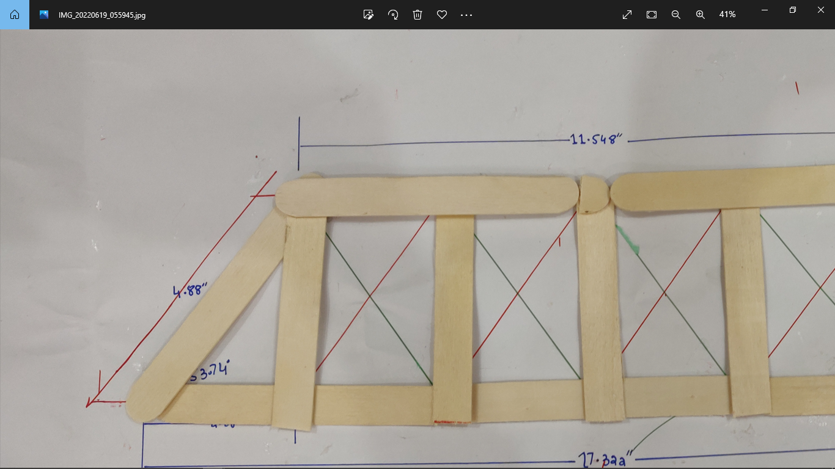

* Cut appropriate size of each stick carefully according to your plan.

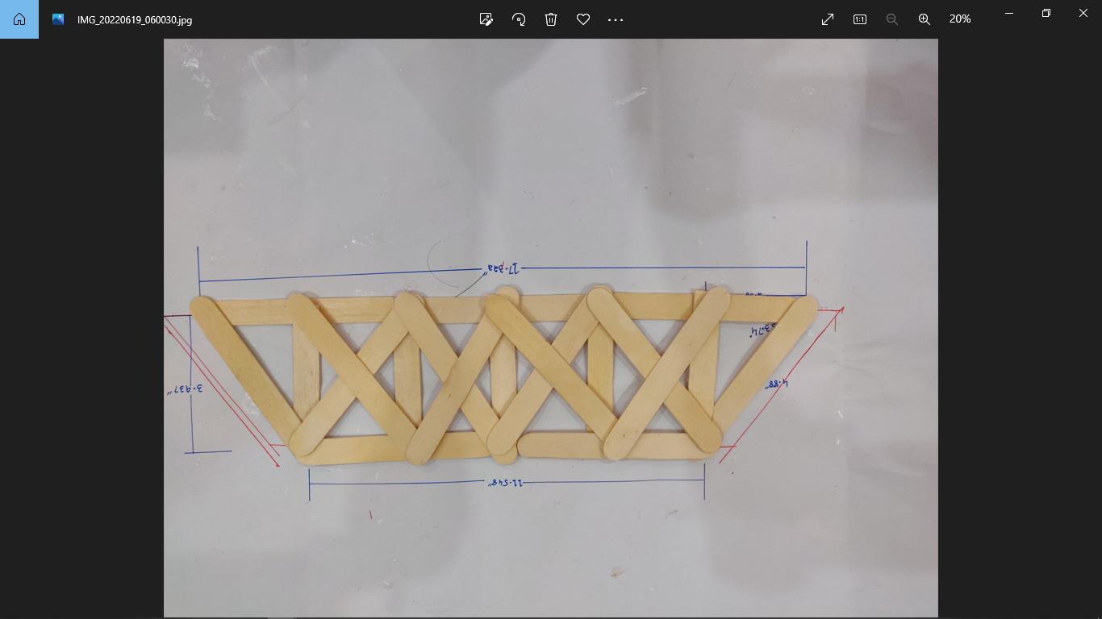

* Start gluing the sticks together. Make sure that you hold them with clippers
* After gluing, place it below a heavy flat sheet of wood. It will make the sticks flatter and prevent it from the deformations.

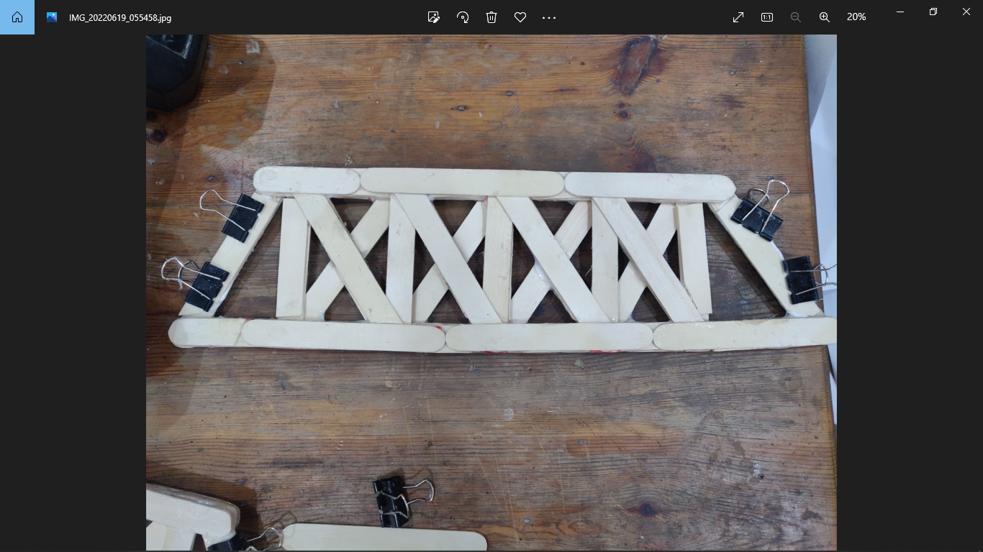

* This design required the top members to be thick because they are in tension. So, use layers of the sticks on top of base layer.
* Wait for glue to dry.

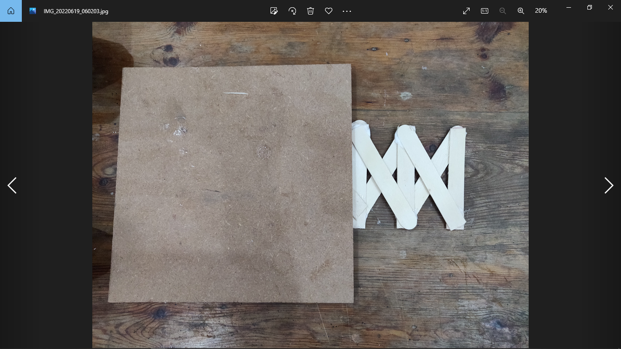

* Now, it is required to make the roof of the bridge.
* Similarly, the floor is made.

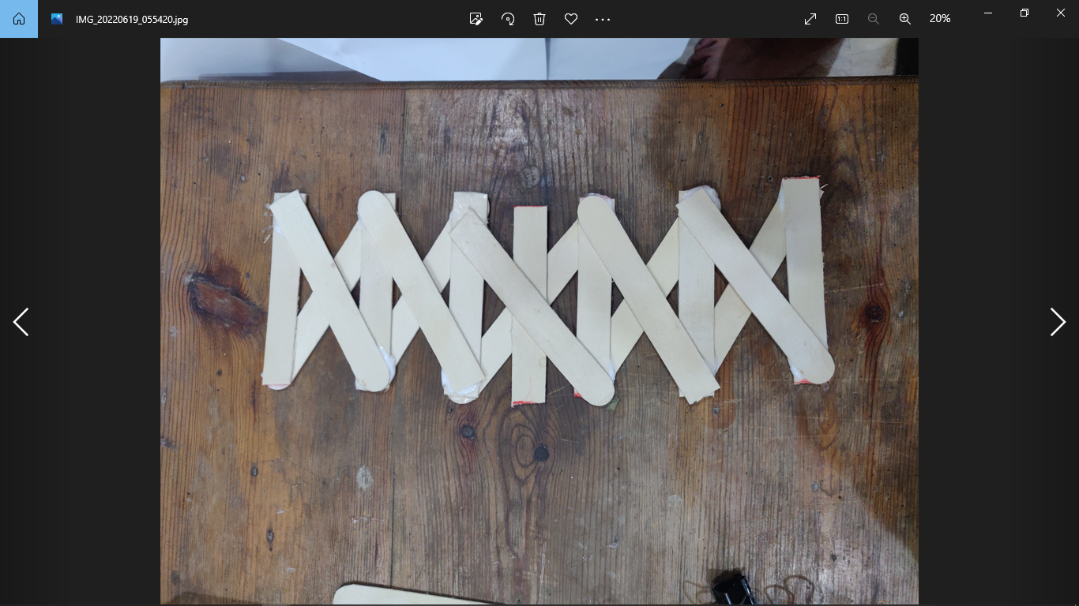

* Now combine all the pieces together with glue.

# Results & Discussion:

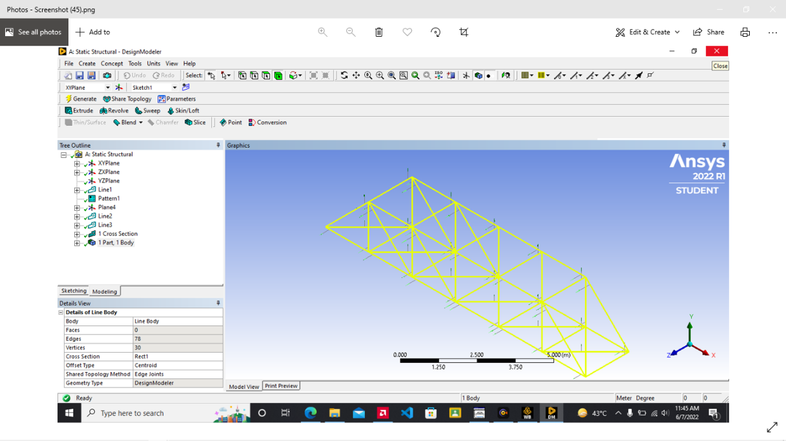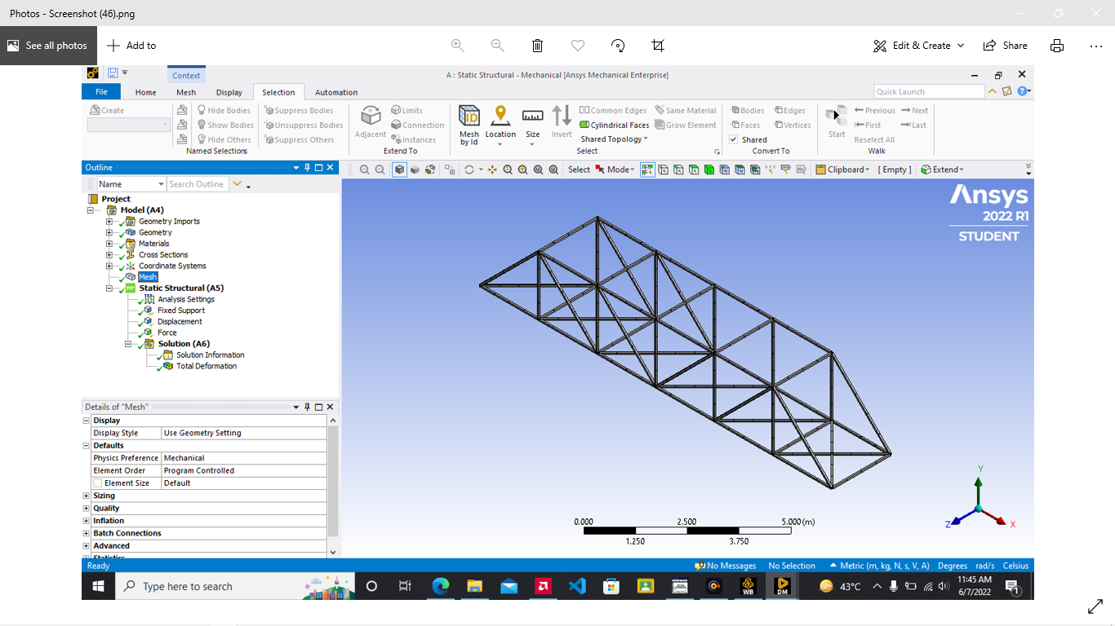

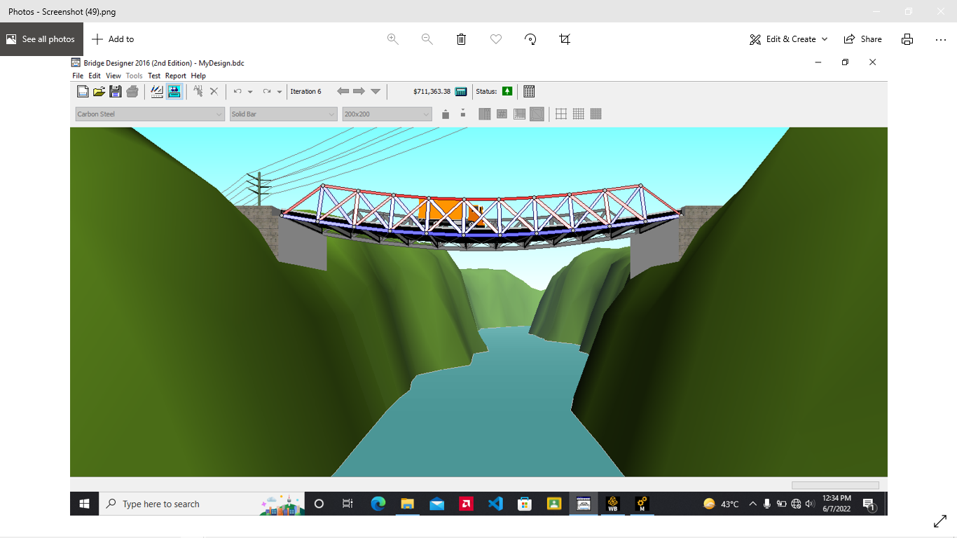

## Pictures:

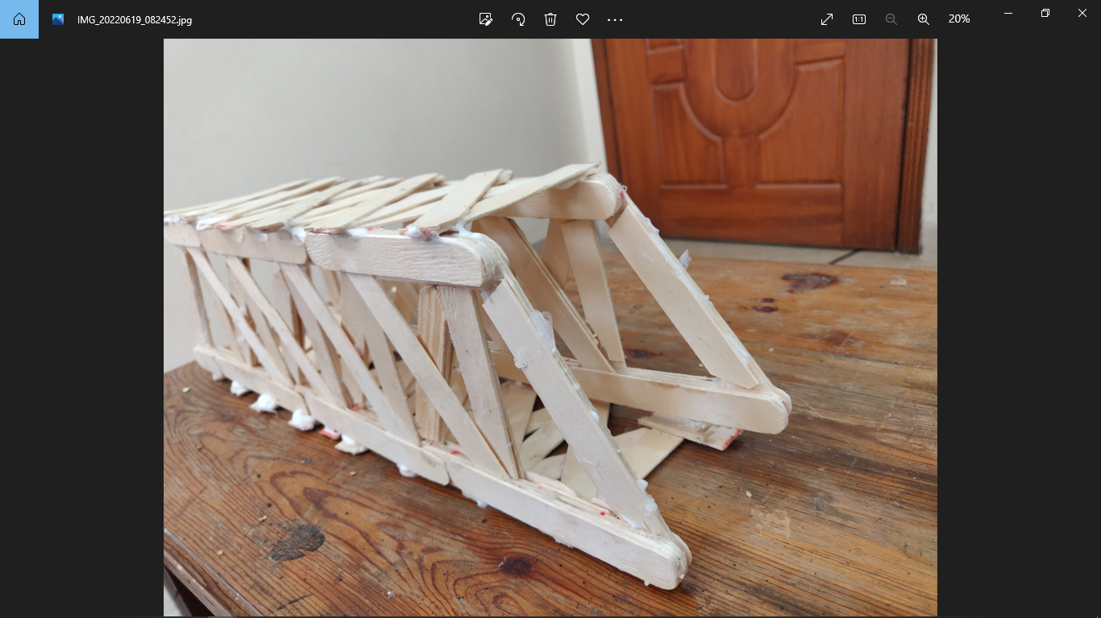

## Loading capabilities:

Md solids picture

As you can see the members which are in tension are the diagonal members and the maximum tensile force a popsicle can hold is much more than the compressive force. So, it is assumed that the failure is not caused by these tension force members. The joints are also assumed ideal. The failure can be expected more by the compressive force members.

1 stick can hold a compressive force of about 24.525 N

5 Stick Member compressive member can hold 122.625 N

3 Stick Member compressive member can hold 73.575 N

**GL= -0.31L (C), GF= 0.1845L (T), EF=0.184L (T)**

**LK=-0.369L (C), LE=0.31L (C), EK=-0.249L (C)**

**ED=0.369L(T), KD=0.31L(T), KJ=-0.5535L(C)**

# Failure:

By calculating, the loads in every member and determining the load specific members can hold, one can specify how much weight the design can handle. This design can hold approx. **23.58kg** of mass. The maximum duration is **1 min**.

# References:

## Software used:

* Ansys Workbench Mechanical
* West point bridge designer
* MD Solids

<https://youtu.be/J0cCA1PAINU>

[Truss – Wikipedia](https://en.wikipedia.org/wiki/Truss)

<https://www.bing.com/search?q=truss&cvid=19b32f25e2b14420bb64a15cd0f253ab&aqs=edge.0.69i59j0l6j69i60l2.851j0j4&FORM=ANAB01&PC=EDGEDB>

[What is the difference between space frame and space truss? (herbertinter.com)](https://www.herbertinter.com/news/what-is-the-difference-between-space-frame-and-space-truss.html)

https://youtu.be/Yu2DOLXkphQ\

[Truss Types, Architecture & Examples | What is a Truss? - Video & Lesson Transcript | Study.com](https://study.com/learn/lesson/truss-types-architecture-examples.html)

<https://youtu.be/4uTbDHFxtHo>

<https://youtu.be/xlwBmrf6240>

<https://youtu.be/CCh8FrmYMnE>